COMMUNITY SERVICE WORK CREW GUIDELINES
WORK CREW OPERATES MONDAY – FRIDAY 8:00 A.M. – 4:00 P.M.

THE WORK CREW MEETING LOCATION IS DIRECTLY ACROSS THE STREET AT “4431 STATE ROUTE 222”.
THE ENTRANCE WILL BE POSTED WITH A
“COMMUNITY SERVICE PARKING” SIGN.
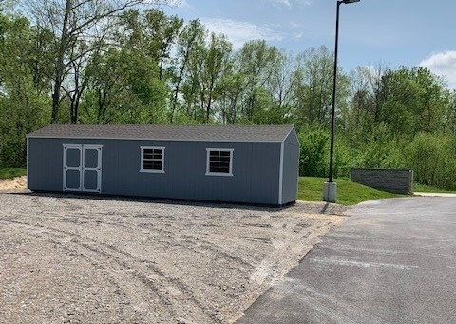

Note: If you arrive after 8:00 a.m., you will be turned away from the work crew no exceptions. Please plan accordingly and arrive by 7:45 a.m.

Crews depart the lot after the guidelines are reviewed. No ½ days permitted. You must work the entire day to receive credit.

- DRESS APPROPRIATELY FOR THE WEATHER – DRESS PREPARED TO WORK OUTSIDE
The work crews usually operate in an outdoor setting, performing roadside litter removal, landscaping, painting, snow removal or other tasks. Please dress prepared to work. Appropriate shirts should be worn. Long pants are recommended due to the working conditions. Work boots are recommended but closed toe/heeled shoes are acceptable. The work crews operate rain, snow or shine, so plan accordingly for the weather. During the winter months it is recommended that participants wear extra layers of clothing, as well as hats, and gloves. Determination of appropriate attire will be at the supervisor’s discretion.

- LUNCH – BRING A PACKED LUNCH OR LUNCH MONEY
Please bring lunch or lunch money. If you pack a lunch, only bring what you will consume. No excessive food items will be allowed on the vans.

- VALUABLES – DO NOT BRING VALUABLES OR LARGE SUMS OF MONEY TO THE WORK CREW
Do not bring any valuables to the work crew. BOOK BAGS AND/OR BACK PACKS are not to be brought to work crew. No exceptions. The Community Service Department is not responsible for lost, stolen or damaged items.

- TOBACCO PRODUCTS – BY PERMISSION USE ONLY
Breaks will be given at the discretion of the work crew supervisors and according to outside agency policy

- CONDUCT – APPROPRIATE BEHAVIOR AND ATTITUDE IS EXPECTED
It is expected that you actively participate and follow all directions of the work crew supervisor in charge. Insubordination will not be tolerated and could be grounds for dismissal from crew. Proper conduct and language is expected at all times. Please be considerate of others around you.

- WEAPONS/DRUGS/ALCOHOL/PRESCRIPTIONS – LOOSE PRESCRIBED MEDICATION NOT ALLOWED
Pocket knives, mace, or any type of weapons are not permitted. A metal detector may be utilized to detect contraband. Participants are not permitted to possess or use any alcohol or illegal drugs at the work site, during lunch, or prior to reporting for work crew. Work Crew supervisors will conduct daily inspections to ensure these items are not in the possession of crew participants. Law Enforcement and/or the Court will be notified if you are suspected of possessing or being under the influence of any illegal drug or alcohol and additional criminal charges may be filed. All prescription medications must be presented to the work crew supervisor and must remain in the bottle in which it was dispensed from the pharmacy. Failure to have medications in the original container will result in dismissal from the crew that day.

- CELL PHONES/RECORDING DEVICES – MUST BE TURNED OFF UNTIL PERMISSION IS GIVEN TO USE
Cell phones and other electronic devices are not permitted to be used while working. Please notify the supervisor should you need to use your phone in case of an emergency. Such devices shall be turned off which will be checked by the work crew supervisor before departing in the van. Once the phone is turned off, it shall remain off until such time supervisor approves it to be turned back on and used during lunch or other designated breaks. Recording is strictly prohibited on the work crew.

I have read and understand the work crew guidelines and agree to adhere to the above instructions as outlined. Failure to abide by these said guidelines may result in dismissal from crew, zero hours credited for the day and /or a probation violation being filed for not following the direction of the work crew supervisors.

__________________Hours to be completed by: _____________________________________________________________________

Signature: X_______________________________________________________________________________________________________
Date
Questions or concerns regarding your Community Service?
Please call 513-732-7147

THE WORK CREWS WILL BE CLOSED ON THE FOLLOWING DATES

Monday, May 25, 2026 – Memorial Day

Friday, June 19, 2026 – Juneteenth

Friday, July 3, 2026 – 4th of July

Monday, September 7, 2026 – Labor Day

Monday, October 12, 2026 – Columbus Day

Wednesday, November 11, 2026 – Veterans Day

Thursday, November 26, 2026 – Thanksgiving Day

Thursday, November 27, 2026 – Day after Thanksgiving

Thursday, December 24, 2026 – Christmas Eve

Friday, December 25, 2026 – Christmas Day

Thursday, December 31, 2026 – New Years Eve

Friday, January 1, 2027 – New Years Day

